Software Testing Report

New York Restaurant Inspection Results

Student Names

Kartik Mathur (s5309927)

Manish Shrestha (s5308120)

Nivethaa Elangovan ( s5298899 )

Table of Contents

1.0 Unit Tests 3

2.0 Coverage Report 4

3.0 Requirements Acceptance Testing 5

# Unit Tests

| **No** | **Test Case** | **Expected Results** | **Actual Results** |
| --- | --- | --- | --- |
| **1.0** | **Test_load_file Function** | **The Function tests the correct csv file is loaded** |  |
| 1.1 | Test a wrong filename | Exception Handled | Exception Handled |
| 1.2 | Test empty input file | Display error message and handles the exception | Display error message and handles the exception |
| 1.3 | Test correct file | The Test is passed | The test passes |
| **2.0** | **test_check_date_range Function** |  |  |
| 2.1 | Date range validation | From date should always be less than to date. Otherwise the code fails | The code is validated and exception is handled. |
| **3.0** | test_filter_data Function |  |  |
| 3.1 | Filtered data returns a value | It should return an dataFrame object between miniumum and maximum date specified | The dataFrame object is returned from the specified dates |
| 4.0 | test_get_col_choices Function | Checks the values returned by the function excludes the list passed as argument |  |
| 4.1 | Passing a valid excluded list which exists as column in csv file | The columns in the argument are excluded and correct list of columns are passed and validated | The output should match the logic and return True |
| 4.2 | Passing and empty excluded list | The function should return all the columns in the data frame and validate | The function returns the columns in the data frame and validated True |
| 4.3 | Passing a list with wrong column name | The function should return all the columns in the data frame and validate | The function returns the columns in the data frame and validated True |
| 5.0 | test_check_column_name Function | Checks given column exists in the list |  |
| 5.1 | Pass column that exists on list | The output returns true | The output is True |
| 5.2 | Pass column that doesn’t exist | The exception is handled | The exception is handled in the code |
| 6.0 | test_SetDataTable Function | Checks the Data Table is set in the GUI | The data table in homepage GUI is loaded successfully |
| 7.0 | test_OnExportToCSV Function | Tests the output csv file should be generated | The output file is generated |
| 8.0 | test_GetNumberRows Function | The length of rows should be generated from the csv and validated correctly | The correct length is asserted. |
| 9.0 | test_GetNumberCols Function | The length of rows should be generated from the csv and validated correctly | The correct length is asserted. |
| 10.0 | test_GetValue Function | It should validate a date object from the specified row and columns | Date object is validated. |
| 11.0 | test_GetColLabelValue Function | It should validate the column label value of the column number specified. | The correct value is returned and validated. |
| 12.0 | test_GetAttr Function | It should return and check the required attribute with column specified. | The column number returns the value and attribute returned is correct. |
| 13.0 | test_groupby_single_column Function | The method should validate the single column returned and check if the object data value is returned. | The output is validated and it is a single column object. |
| 14.0 | test_groupby_double_column Function | The method should validate the double column returned and check if the object data value is returned. A dictionary if violation code data is passed. | The output is grouped based on the Violation code and animals and dictionary is used to group them. The output returns an object and is validated. |
| 15.0 | test_get_unique_col_values Function | Unique column value should be returned for a given attribute. | Unique column values is returned. |
| 16.0 | test_OnDateSelected Function | Should check the click event in the GUI for the selected date. | The Date is checked and validated. |
| 17.0 | test_OnFromDateSelected Function | Should check the from date selected field event in the UI. | The from date Is checked and asserted. |
| 18.0 | test_OnViewAll Function | Should check the ViewAll button in dashboard GUI is working. | The event passed triggers a ViewAll Details button and should give details validated. |
| 19.0 | test_OnHomeTabSelected Function | The homepage tab should be displayed. | The Homepage tab is displayed. |
| 20.0 | test_OnDashTabSelected Function | The GUI of Dashbaord tab should be validated. | The Dashboard tab is validated. |

# Coverage Report

We Evaluated coverage by the following commands:

1. coverage run -m pytest

This command gave us the below output. This code runs all the unit test cases written in test_*.py file using the pytest library.

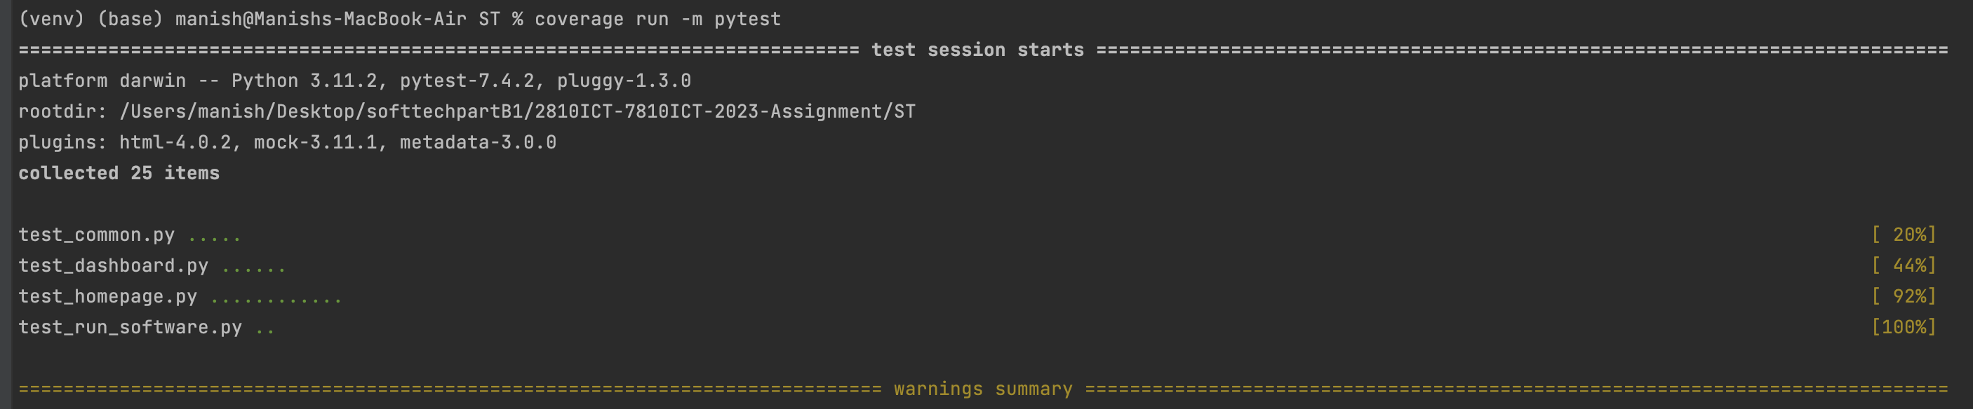

1. coverage report

The coverage report can be seen in the terminal using the above command.

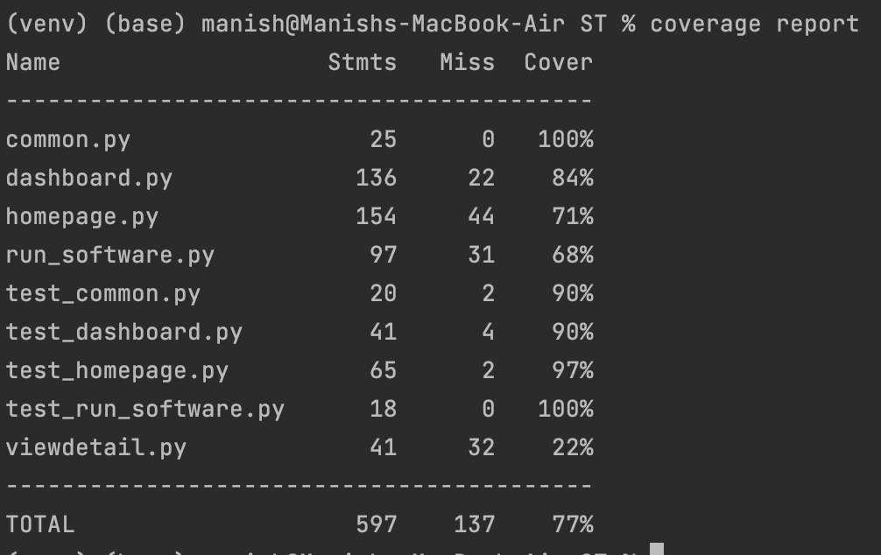

1. coverage html -i

This command generates the report in an HTML format and the report is generated as index.html.



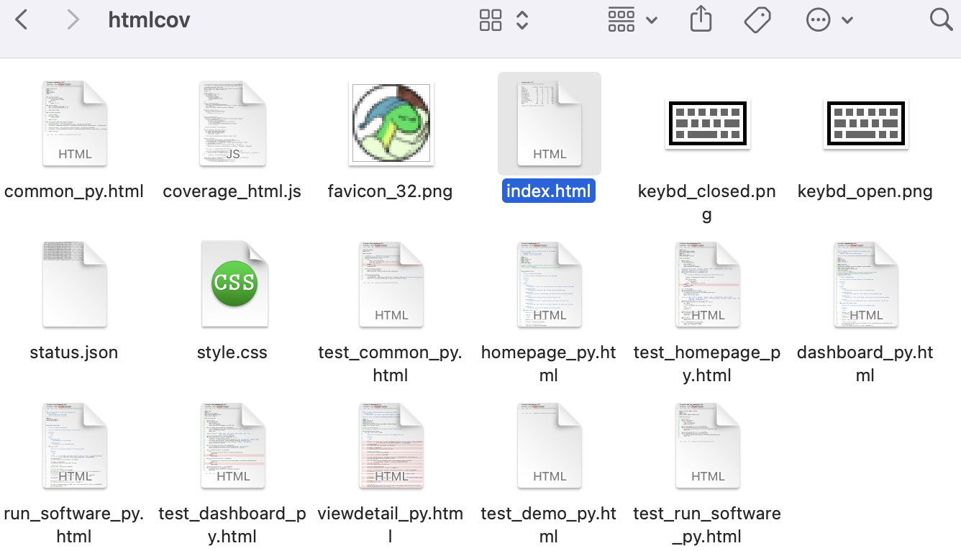

The index.html gives us the overall coverage percentage and percentage of the code covered for each python file.

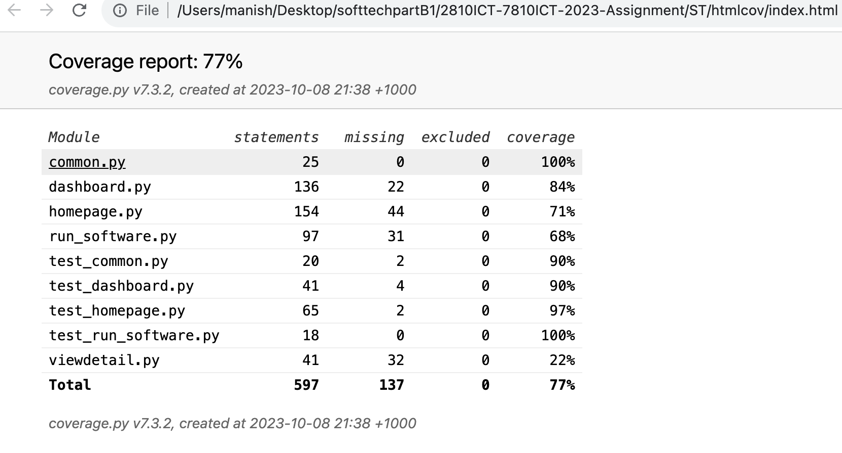

We can observe the following findings from the above report:

1. We can see that all the methods in common.py are covered.

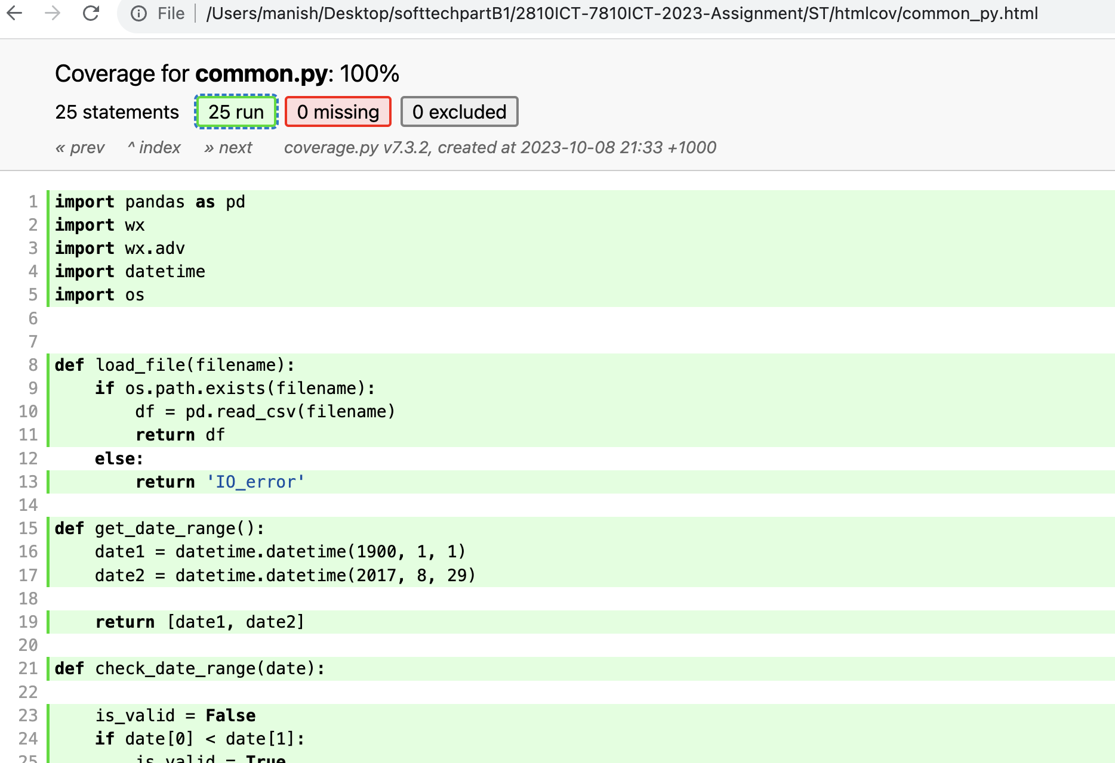

1. 84% of dashboard.py is covered. Most of the methods are covered but are shown missing by the coverage report as the tests are triggered by the user events and not called by Python code for example:

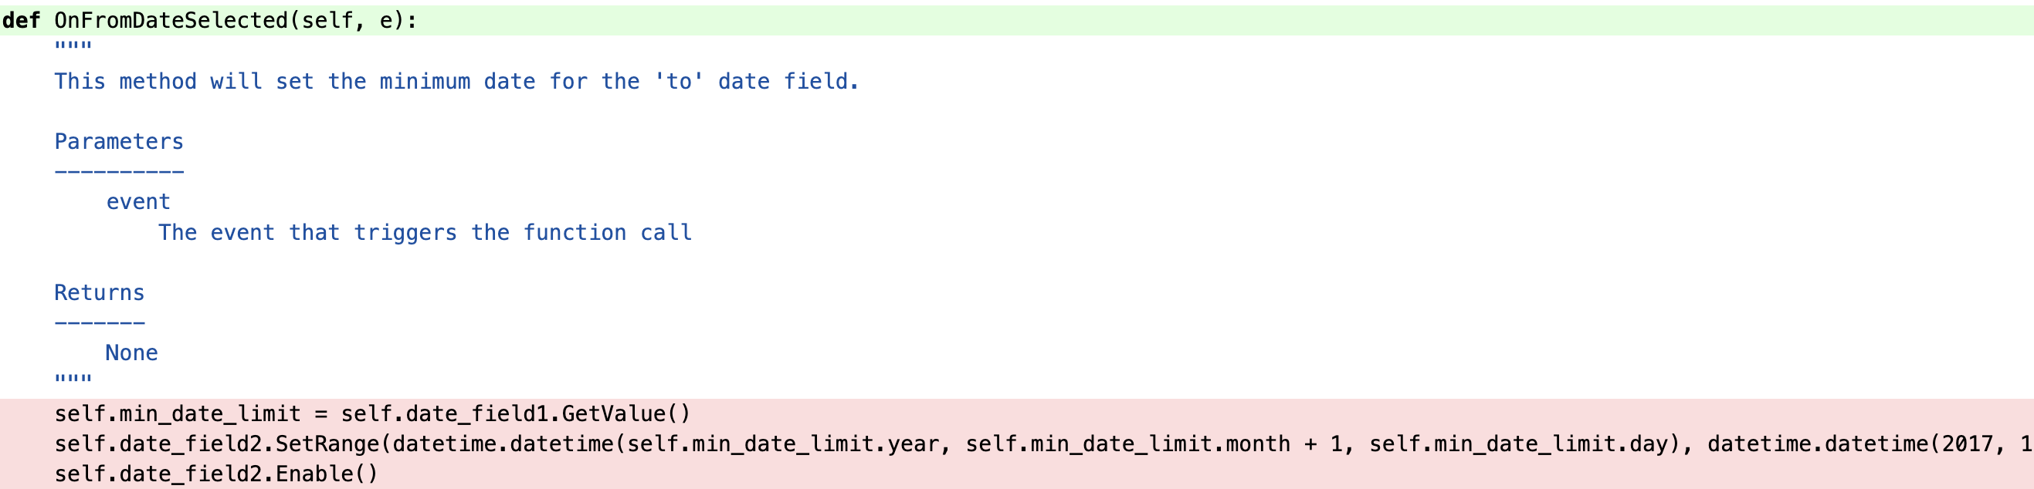

Although the code is tested, the coverage report does not count it in the coverage report due to this. However, it is tested and exceptions are handled. These methods could not be tested directly by the code and called as method as it required some GUI event to trigger the method.

1. We could cover 71% in the homepage.py.

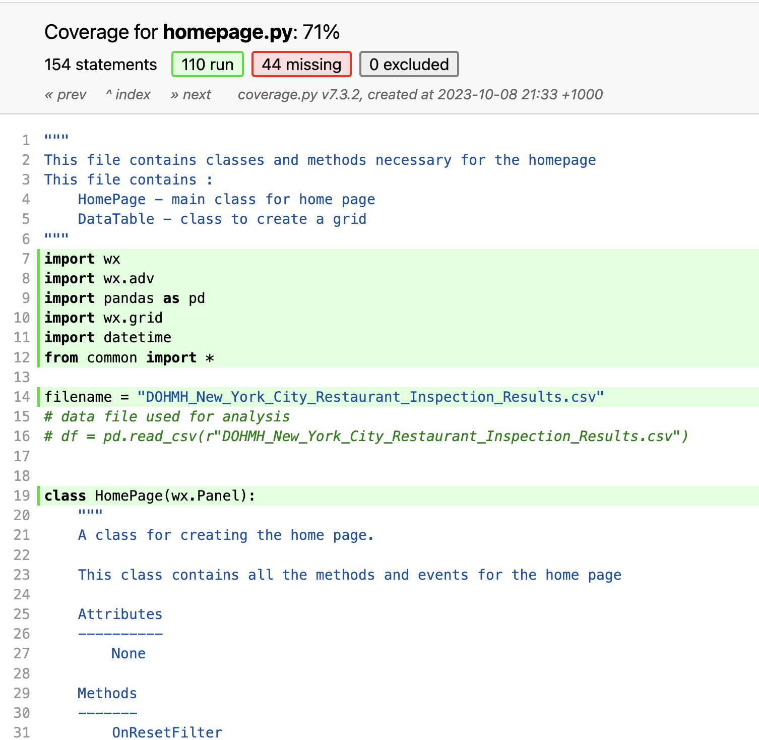

Also, some of the methods were not included in the coverage report although they have been tested. For example, The OnFromDateSelected and Reset button in homepage.

This button requires an external event to perform the action hence it cannot be called manually. This needs to bind with some event. So, it’s a similar case to observation 2.

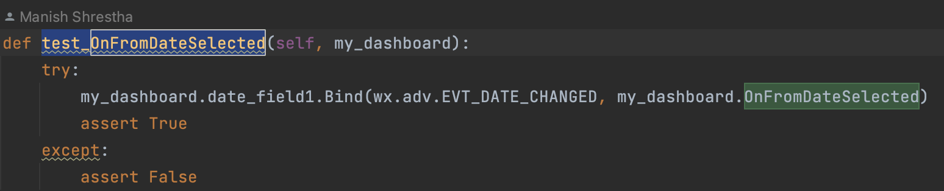

1. 68% of run_software which loads the python files and triggers all the classes and is the main program to run for the software.

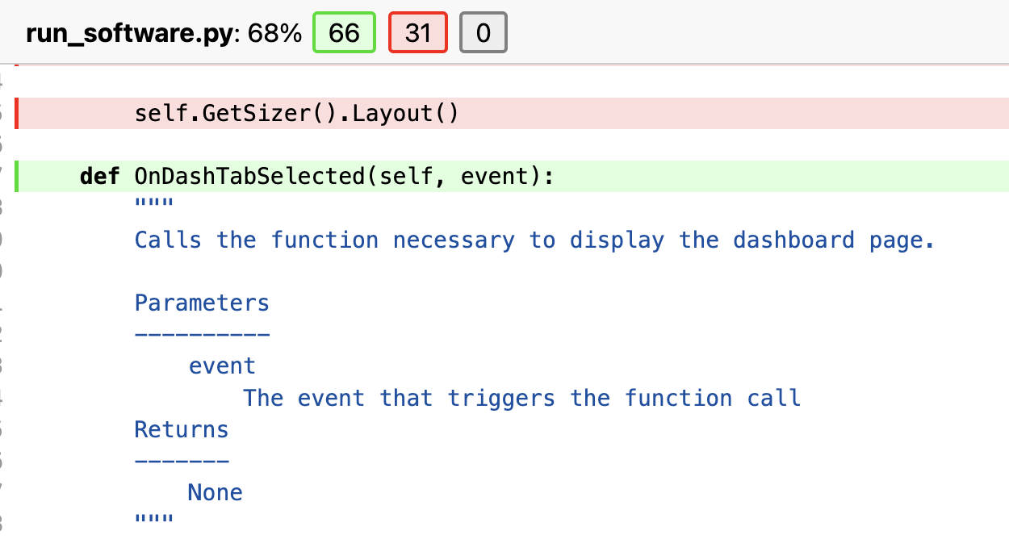

The important parts of the codes are covered in testing. However the testing of events are not shown in the coverage report.

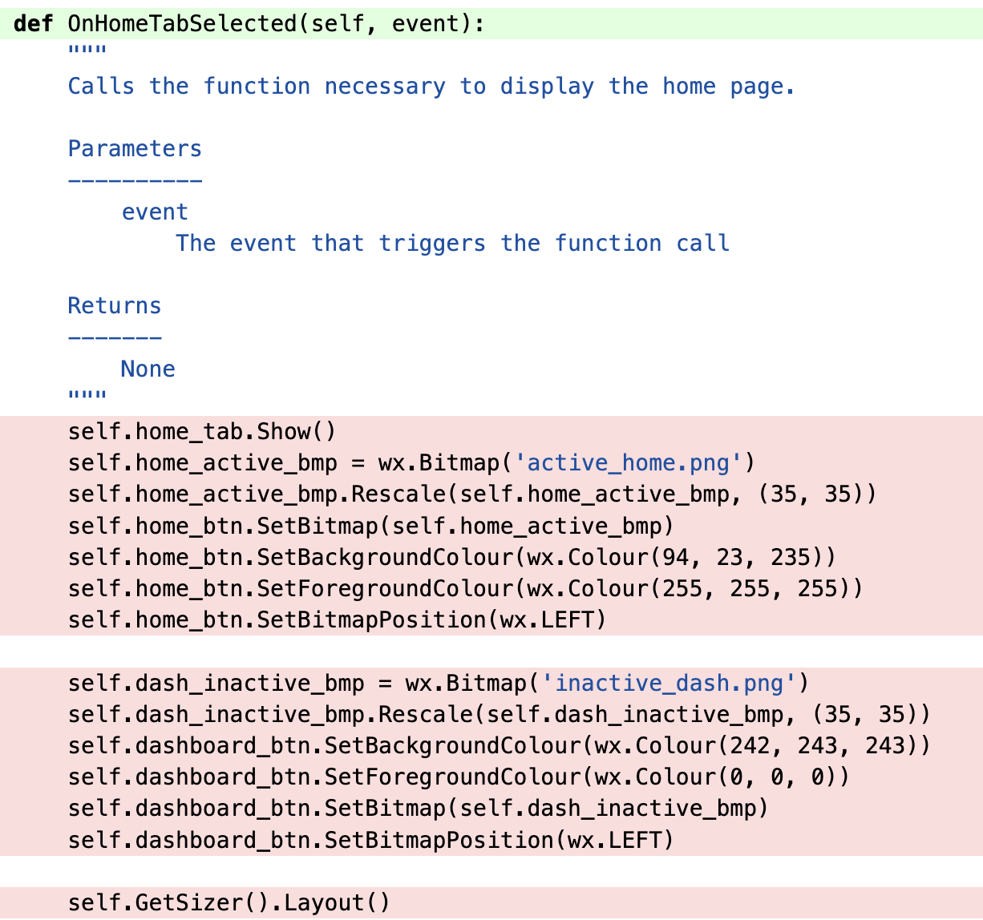 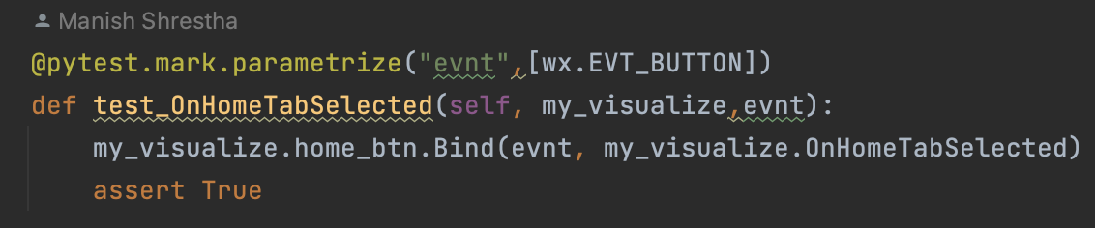

1. 22% tests are covered in viewdetail.py. This is used in the dashboard page and tested by binding with an event. Hence the coverage is not displayed. However it is tested.

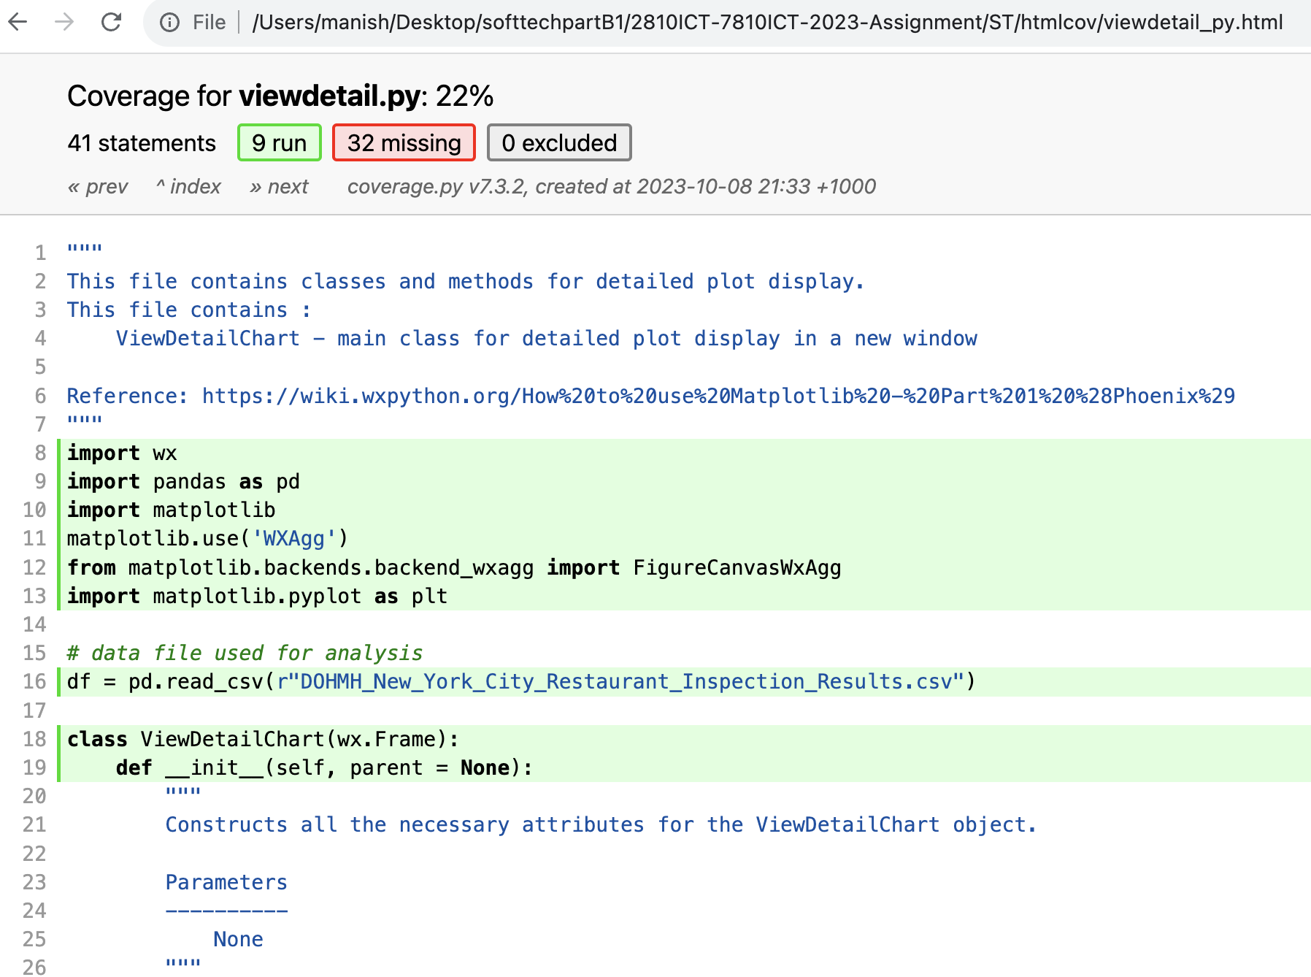

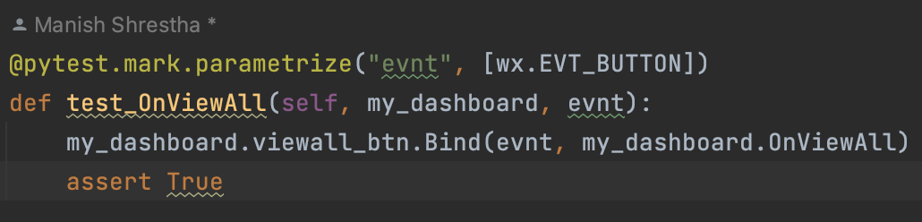

# Requirements Acceptance Testing

| **Software  Requirement No** | **Test** | **Implemented (Full /Partial/ None)** | **Test Results (Pass/ Fail)** | **Comments (for partial implementation or failed test results)** |
| --- | --- | --- | --- | --- |
| 1 | Accept multiple file names as arguments from the command line | Full | Pass |  |
| 2 | Display the details of all valid files | Full | Pass |  |
| 3 | Display an appropriate message if a file does not exist or if a file name is invalid | Full | Pass |  |
| 4 | Display a message if an argument is a directory instead of a file | Full | Pass |  |
| 5 | File name can be a simple file name or include the full path of the file with one or more levels | Full | Pass |  |
| 6 | file names must start with an alphabetical character | Full | Pass |  |
| 7 | Valid file name extensions must be 3 or 4 alphabetical characters preceded by a dot) | Full | Pass |  |
| 8 | Directory/level names must start with an alphabetical character to be considered valid | None | Pass | The code works for the Test but is not validated. |
| 9 | The program should be able to accept as many levels for each file name as the user wants to input. This is limited only by the number of levels allowed in Windows (approximately 120) | None | Pass | The code works for the Test but is not validated |
| 10 | The system shall have two tabs with pages: the home page and the dashboard page. | Full | Pass | The Visualize class ensures two classes exist for homepage and dashboard with separate tabs |
| 11 | The system shall display all the data in a tabular format on the home page. | Full | Pass | The Data table is displayed and validated in the homepage and is displayed in tabular format |
| 12 | The system shall display the necessary data filters on the dashboard and home page which is fromdate, toDate and column selection dropdown and search textfield | Full | Pass |  |
| 13 | The system shall allow the user to select a date range from the date picker in the filter section. | Full | Pass |  |
| 14 | The system shall allow the user to search for certain column attributes of dataset based on keywords entered in the search field in the filter section. | Partial | Pass | The code works fine for a scenario so did not check all. |
| 15 | The system shall allow the user to view violations over different suburbs as a pie plot/chart. | Full | Pass | The GUI for Dashboard is tested |
| 16 | The system shall allow the user to view violations related to animals over a time period as a timeseries plot | Full | Pass | The GUI for Dashboard is tested |
| 17 | The system shall allow the user to view violations related to animals over different suburbs as a bar chart. | Full | Pass | The GUI for Dashboard is tested |
| 18 | The system shall allow the user to view the violation count based on cuisines as a bar chart. | Full | Pass | The GUI for Dashboard is tested |
| 19 | The system shall allow the user to export the data as an Excel or spreadsheet. | Full | Pass | The export button is tested and output file generated is also tested. |
| 20 | The ViewALL button shall navigate to Violation count per cuisine plot | Full | Pass | The ViewAll button in dashboard opens a new window to plot Violation count per cuisine and tested. |